# CS 340 README Template

## About the Project/Project Title

CRUD operation. We know simple word in database called CRUD. In this project, CRUD operation will be done by Python.

## Motivation

After learning of CRUD operation in MongoDB, I thought to create a project which will be run by Python integrated by pymongo library in Dashboard.

## Getting Started

We have given a well written easy to understand document from our professor to crate a Python project to create CRUD Operation by Python script combining poltly library. The instruction includes to authenticate database by connection in a port with credential and showing data in front end.

## Installation

Python

PyCharm

MongoDB

PyMongo

Poltlydash

NumPy

Panda

## Usage

I have integrated the project by compiling three Python files. Class and function used and function calling by test.ipynb file.

### Code Example:

#import main file  
import main as m  
  
#import logic to pass over when call.  
import parameter   
  
#called class  
p*1*=m.AnimalShelter()  
#Called function to show data when click on button.

### Tests

I have developed main.ipynb Python script to test database to test my Python functionality. It does work and result comes up as expected by read query.

### Screenshots

Default output when run the application

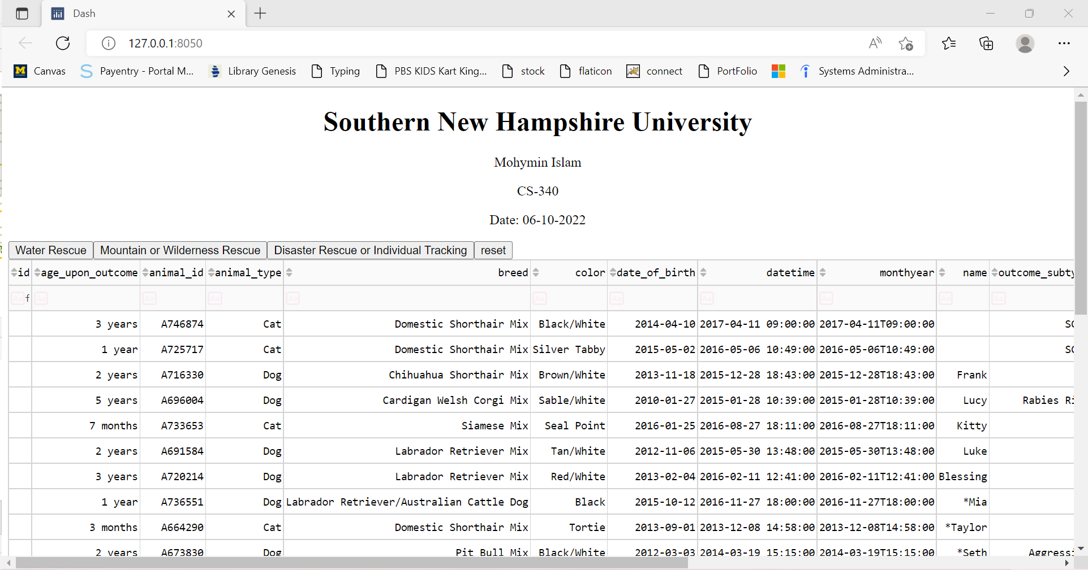

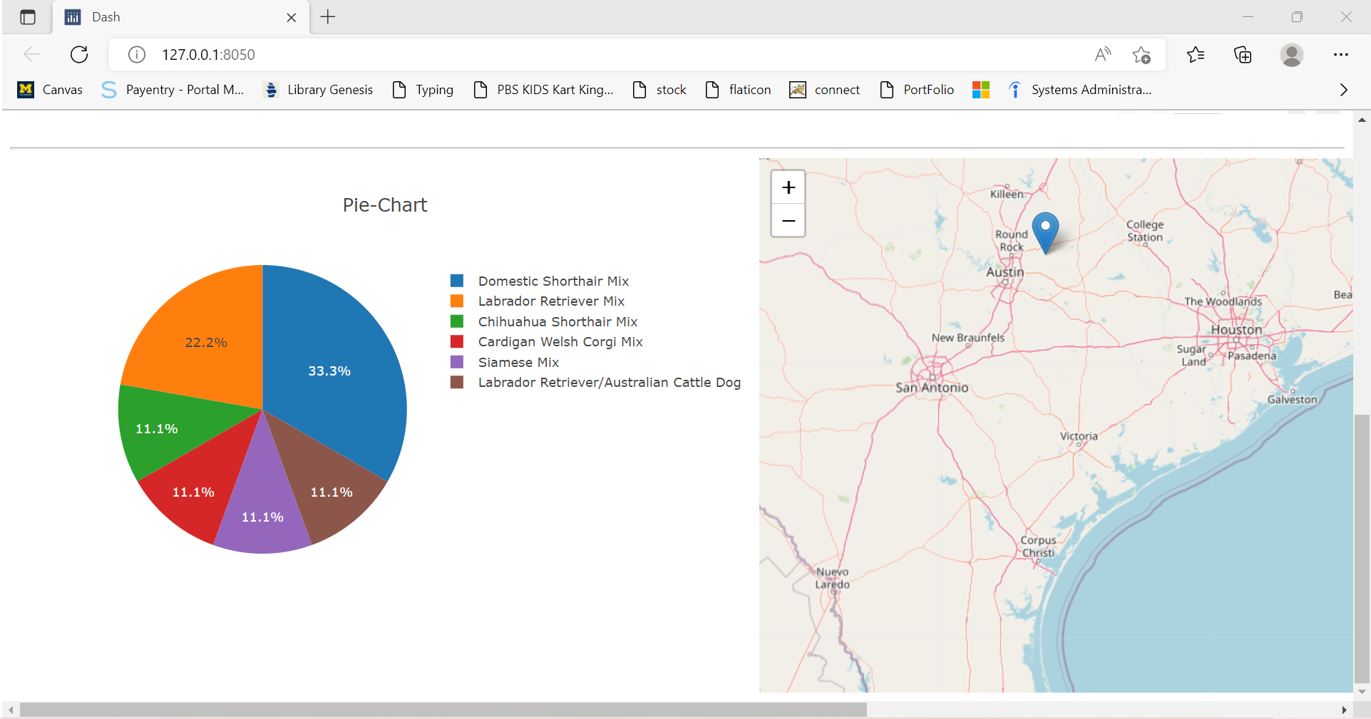

When click on Water rescue button

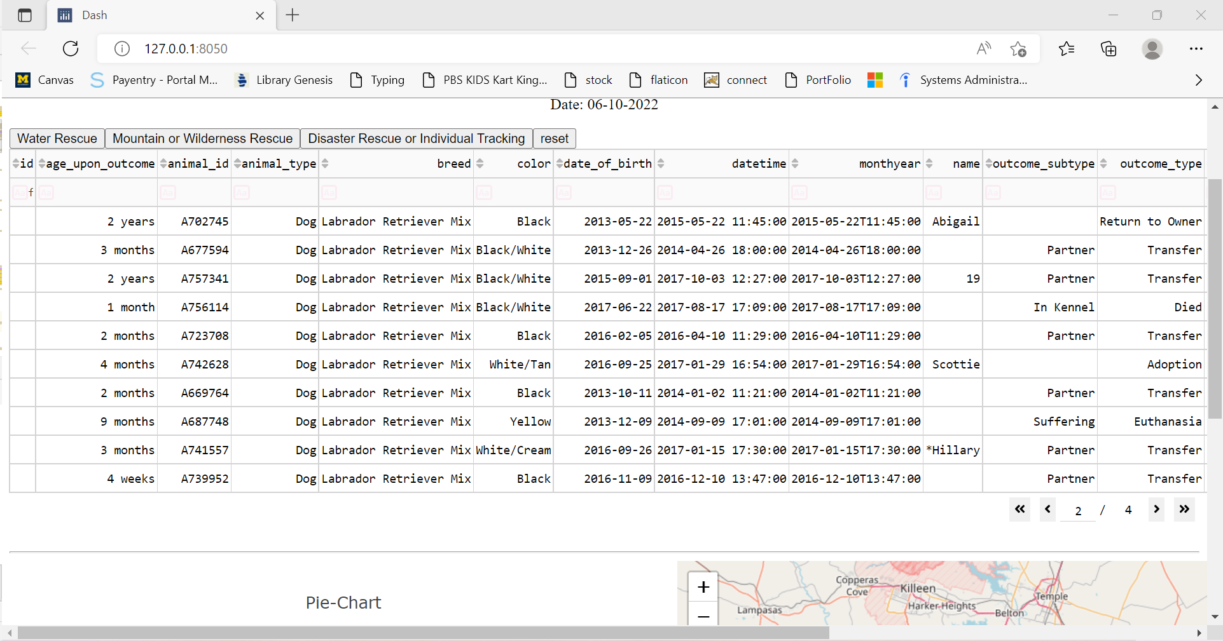

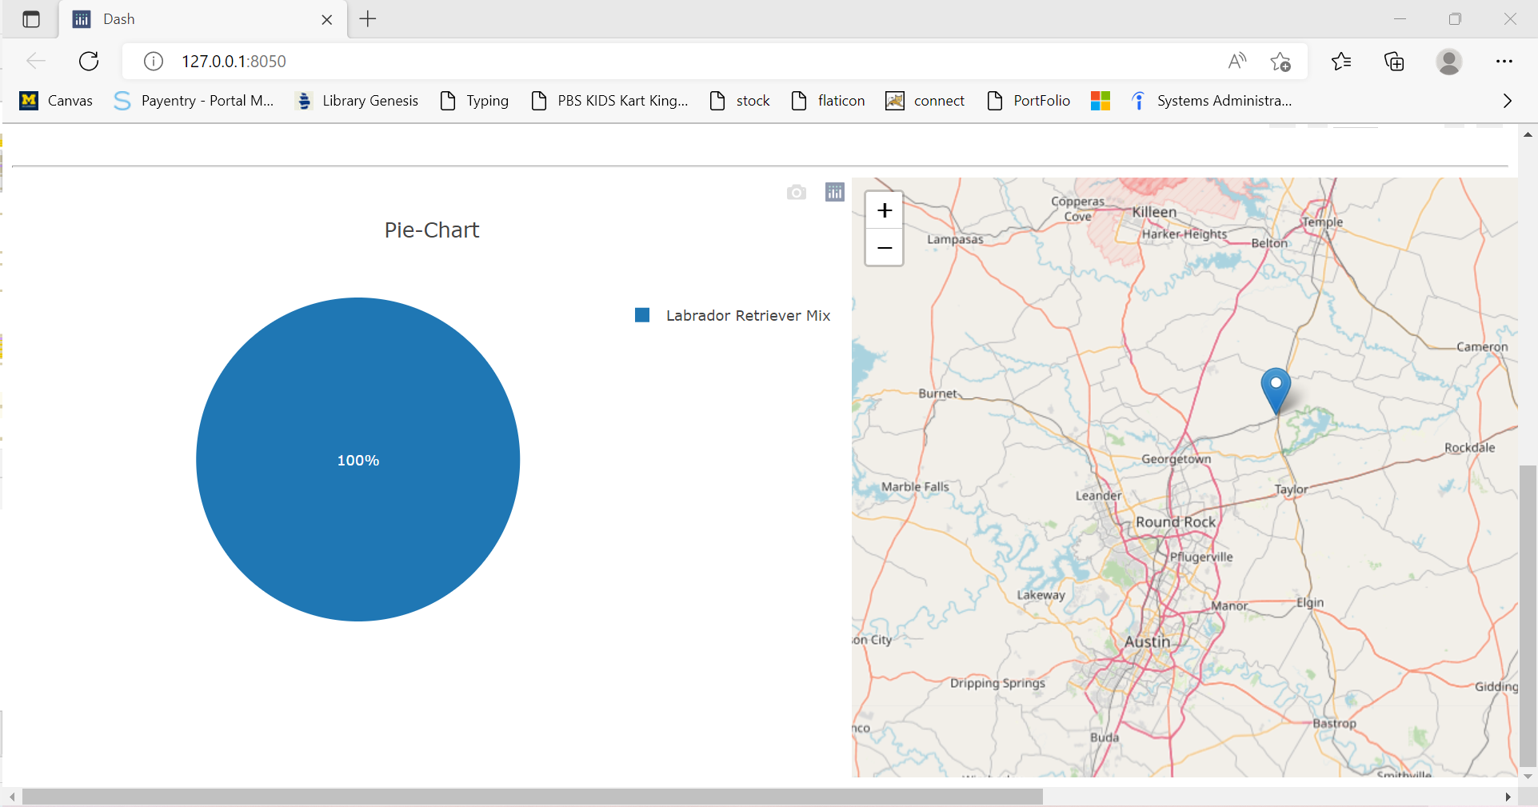

When click on Mountain button

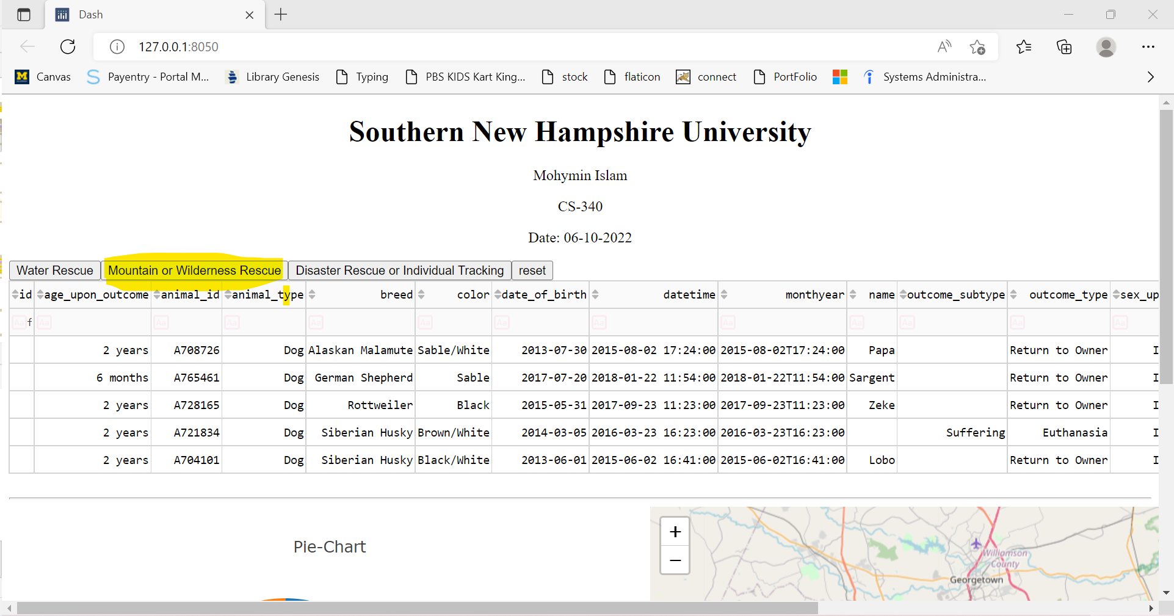

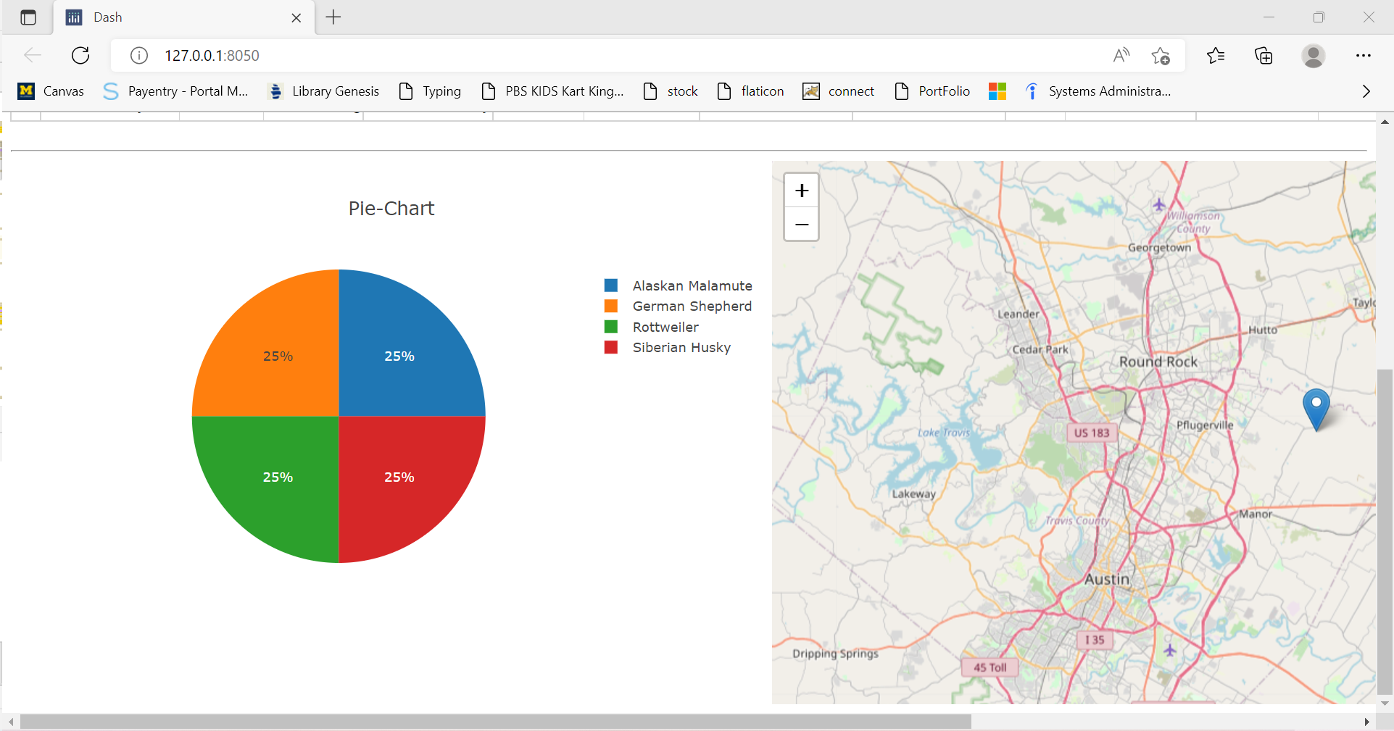

When Click on Disaster Rescue Or Individual Tracking

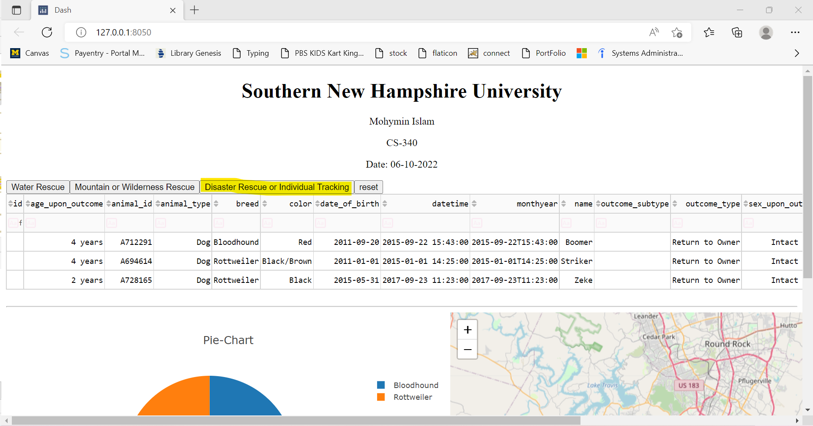

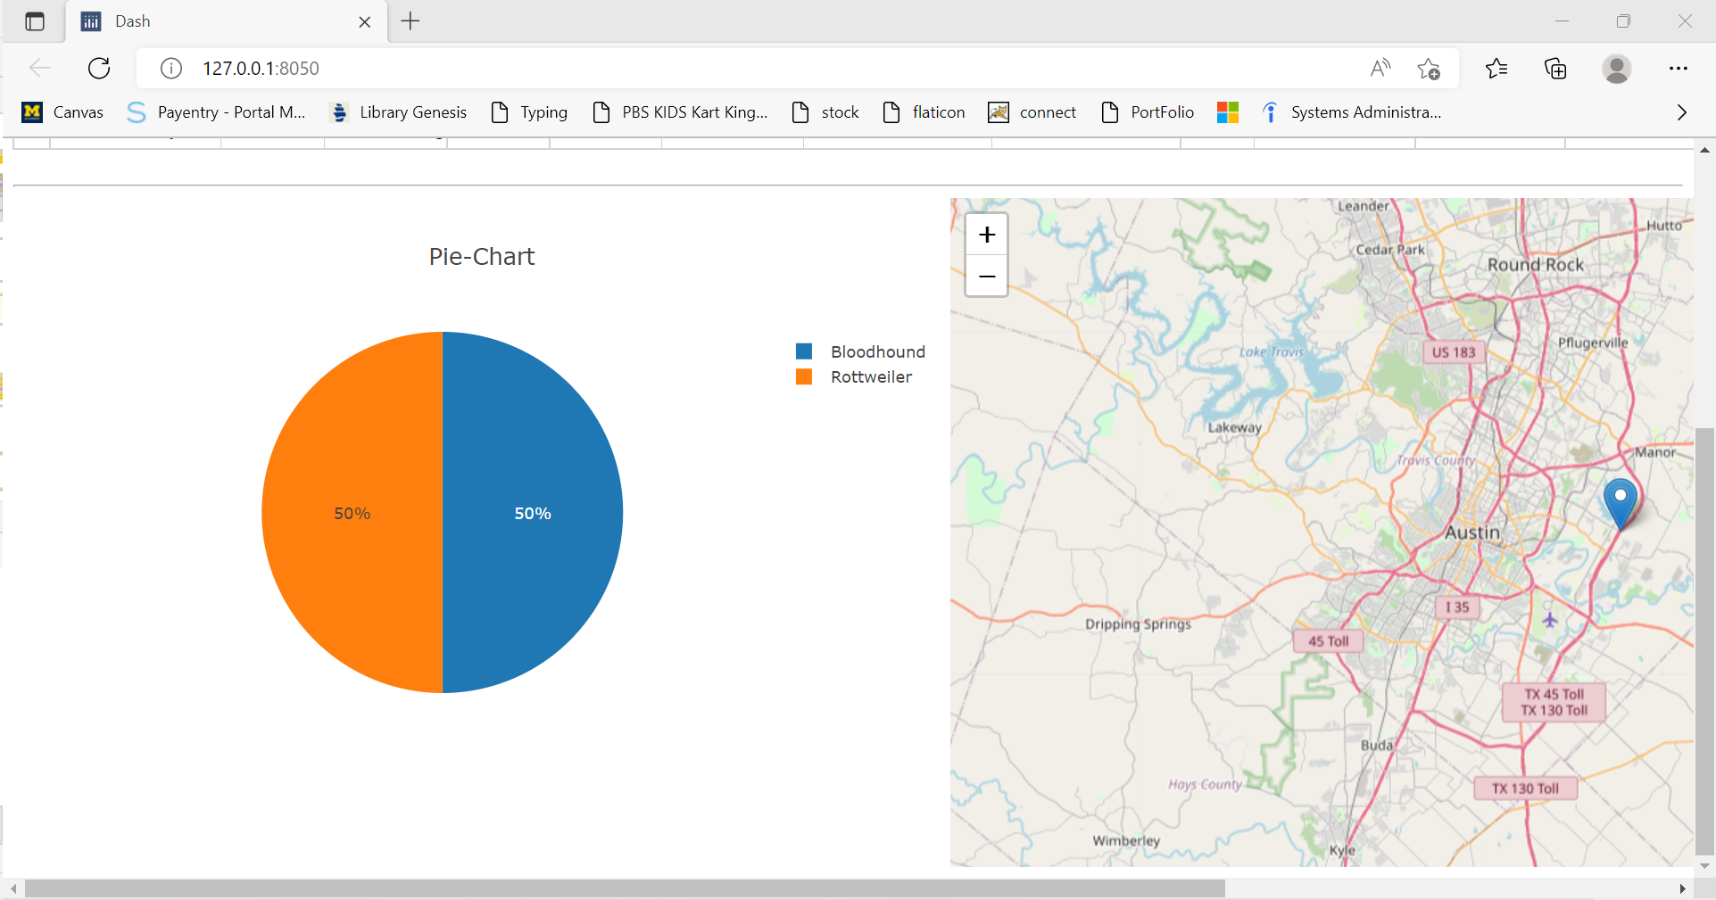

When click on Reset button

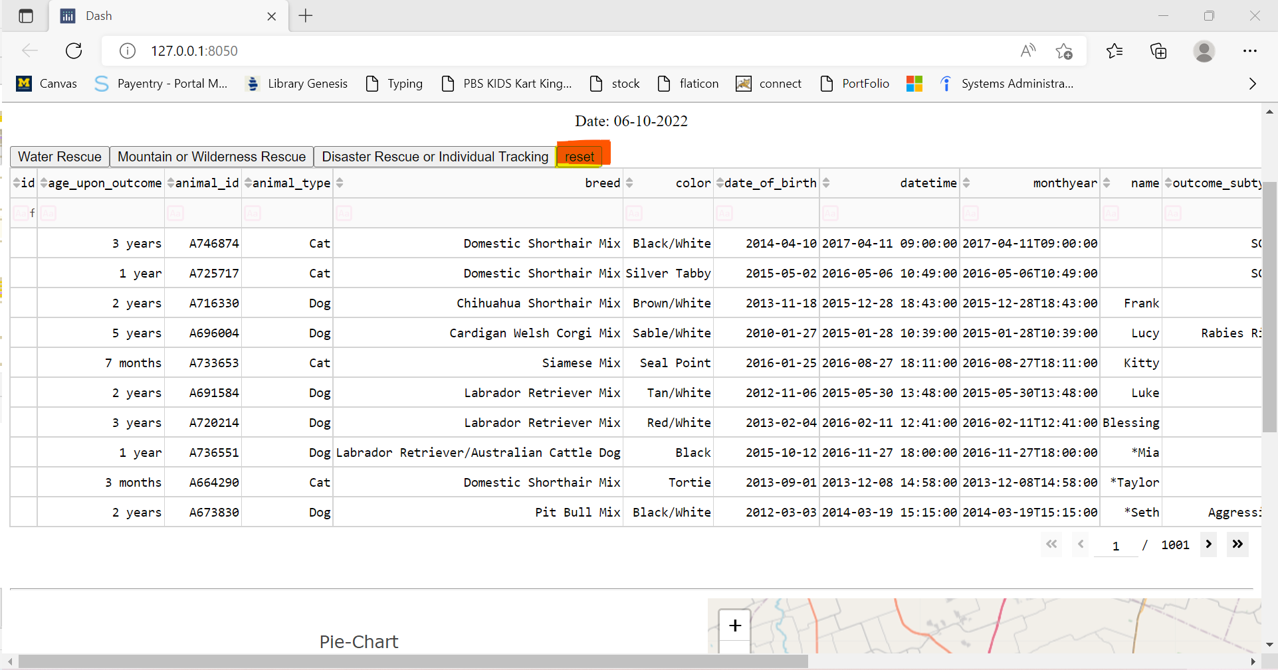

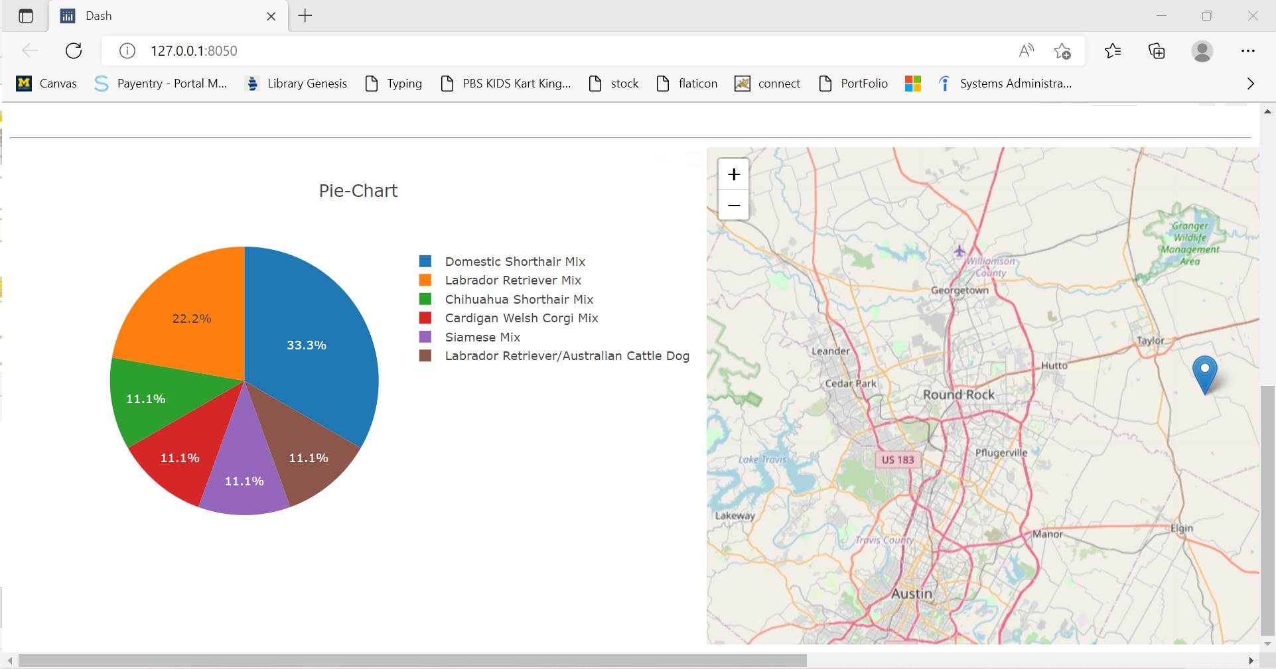

#### CRUD functionality explanation

I have developed CRUD functionality of MongoDB by using python and PoltlyDash with NumPy and Panda. I have used four button each button call read functionality.

#### Read function and execution screenshot

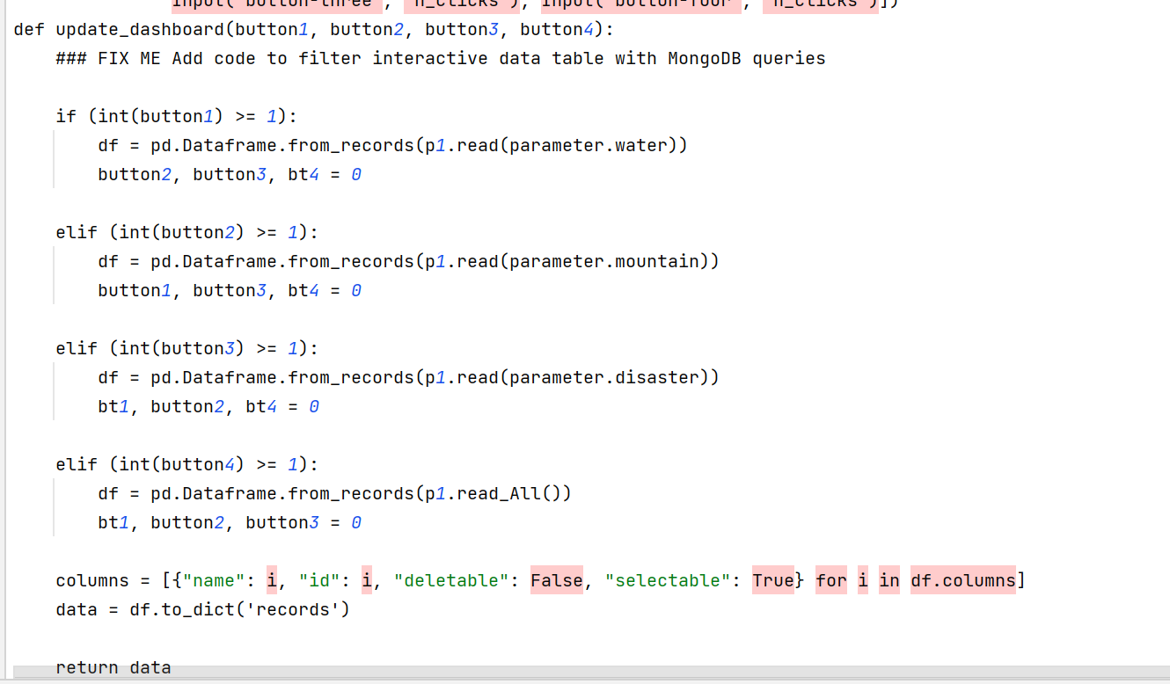

IPYNB file call functionality by calling read when I click each button. Function call and provide query to read function which execute data.

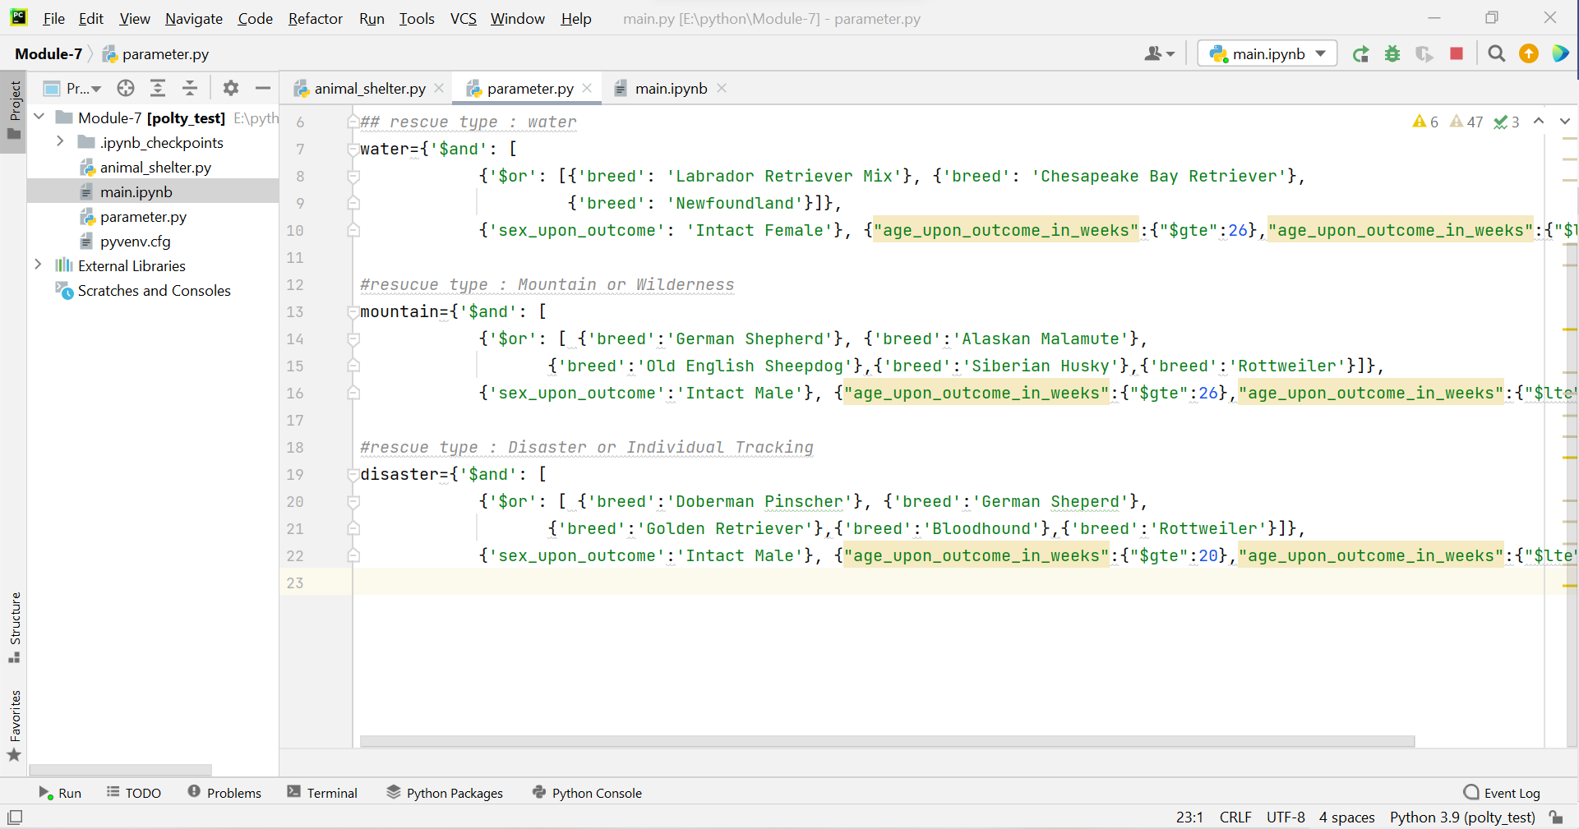

After pressing each button, it does call specific function by providing Read query. Read query

Provide query to function.

## Contact

Mohymin Islam

CS-340 Client/Server Dev.

Southern New Hampshire University